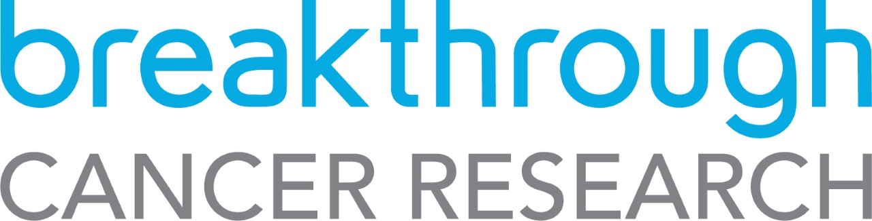

Cancer Immunology Research Fellowship (CIRF 2021)
Breakthrough Cancer Research in conjunction with ‘5 For The Fight’

Expression Of Interest (EOI) CIRF 2021.

Deadline 13th September 2021, 17:00 GMT

Document | Section | Limits
Applicant CV | Name | 5 pages in total
 | Contact details (address, email, phone)
 | Current Position
 | Education (including date of PhD award)
 | Employment to date
 | Grant history (current, pending, completed): Dates active, amount, grand body, role, percentage time commitment)
 | ORCID Number
 | Publication output: Total number peer-reviewed publications; list of peer reviewed publications (Vancouver style); list of other publications.
 | Impact e.g. Conference participation, patient contact
 | Awards received
Document | Section | Limits
Proposal | Title | 30 words
 | Keywords | 15 words
 | Duration of award (months)
 | Scientific Abstract | 250 words
 | Lay abstract | 250 words
 | Alignment with BCR priorities | 250 words
 | Potential impact | 250 words
 | Collaborator details (max 5). Name, title, ORCID Number, role of collaborator in proposal | 2 pages max
Appendix 1 | EOI Requirement and Check list | 1 page

